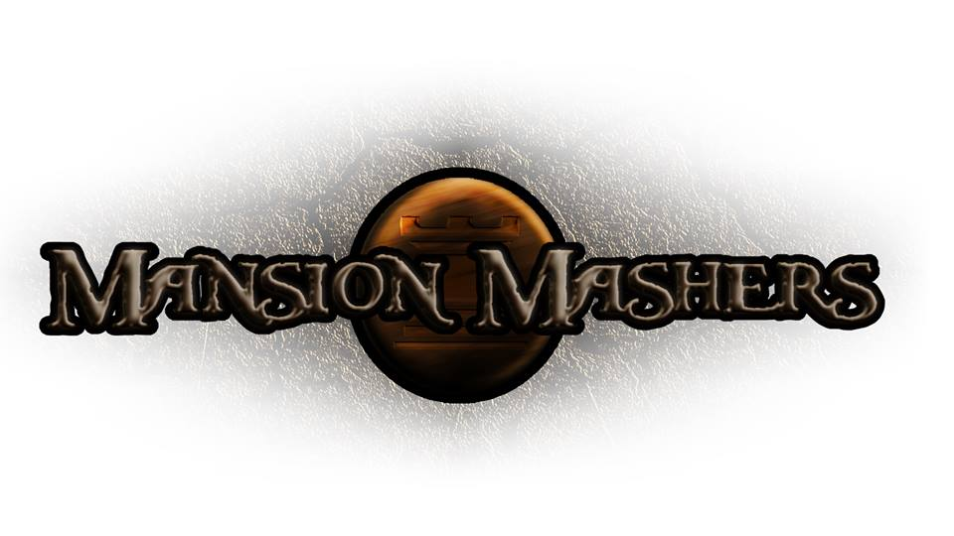**Weekly Production Report**

**Week 3**

**January 23, 2014**

**By Juli Gregg**

**High Concept**:

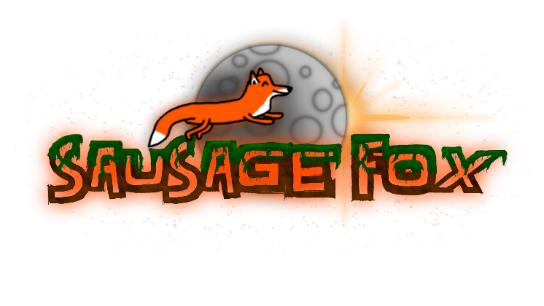A 2-D cartoon fantasy dungeon crawler side-scrolling hack and slash game.

**Producer:**

Juli Gregg

**Tech Director**:

Dan Muller

**Game Designer**:

Luke Conlon

**Project Manager**:

Kaden Nugent

Project Status:

Green

Current Milestone:

Concept/Engine Proof

Accomplishments:

|  |  |
| --- | --- |
| **Juli Gregg** | Worked to implement Game State Manager. Completed work on Game Design Document and Game Concept Presentation. |
| **Dan Muller** | Worked on strengthening Player, Sprite, and Animation code. Implemented and began testing most physics and created basic enemy prototypes. |
| **Luke Conlon** | Created art assets including demo level background, HUD design, and items. Set up multiplayer HUD design to follow camera/characters. |
| **Kaden Nugent** | Worked on collision detection and resolution. Also edited current object manager for proper memory allocation. |

Objectives:

|  |  |
| --- | --- |
| **Juli Gregg** | . |
| **Dan Muller** |  |
| **Luke Conlon** |  |
| **Kaden Nugent** |  |

Highlights:

We are currently ahead and everyone is consistently working in order to remain ahead. For our concept presentation we have some physics implemented, movement, level changing, some collision, sample backgrounds and HUD design, and camera movement.

Risks & Mitigations:

|  |  |
| --- | --- |
| **RISKS:** | (1) While getting ahead is good it may result in code that is less efficient or poor implementation.  (2) There was a legitimate concern about lack of space to work in Edison/Tesla with good internet connection. We commit to our repository a lot and without internet our builds may become harder to merge.  (3) We have a lot of plans for this game that due to limited amount of time we may not be able to implement everything that we want to. |
| **MITIGATIONS:** | (1) We have attempted to make our code easy to swap in and out if we need to replace code in the future once we learn proper implementation through CS230.  (2) Discussed areas to work for freshman with powers sources with student affairs. Also began working together outside of school.  (3) Attempt to keep a realistic timeline and slowly weave in stretch goals as we achieve the basic requirements to make our game functional and fun. (Ex. Multiplayer) |

**Signatures**

_____________________

Juli Gregg

_____________________

Dan Muller

_____________________

Luke Conlon

_____________________

Kaden Nugent